STUDENT PERFORMANCE
PREDICTION

A Project Report On
STUDENT PERFORMANCE PREDICTION
Submitted in partial fulfillment of the requirement for the award of the degree of
BACHELOR OF SCIENCE (COMPUTER SCIENCE)
BY
PRATIK SHARAD NIKAM
Seat No. :-
Under the esteemed guidance of
MISS. ASHWINI SAMADHAN SHETH

DEPARTMENT OF COMPUTER SCIENCE
I.C.S. COLLEGE OF ARTS, COMMERCE & SCIENCE, KHED
(Affiliated to University of Mumbai)
KHED, 415709
MAHARASHTRA
2025-2026

PROFORMA FOR THE APPROVAL PROJECT PROPOSAL
PNR NO. SEAT NO.

Name of the Student: Pratik Sharad Nikam
Title of the Project: Student Performance prediction
Name of the Guide: Miss. Ashwini Samadhan Sheth
Teaching experience of the Guide: 11 years
Is this your first submission? Yes

Signature of the Student Signature of the Guide
Date: Date:

Signature of co-ordinator
Date:

I.C.S COLLEGE OF ARTS, COMMERCE & SCIENCE, KHED
(Affiliated to University of Mumbai)
KHED-MAHARASHTRA
DEPARTMENT OF COMPUTER SCIENCE

CERTIFICATE
This is to certify that the project entitled, “STUDENT PERFORMANCE PREDICTION”, is bonafied work of PRATIK SHARAD NIKAM bearing Seat No. : submitted in partial fulfillment of the requirement for the award of the degree of BACHELOR OF SCIENCE in COMPUTER SCIENCE from University of Mumbai.

Internal Guide Coordinator

External Examiner

Date: College Seal

ACKNOWLEDGEMENT

Firstly we thank to god almighty whose blessing were always with us and helped us to complete this research work successfully.
I sincere thanks to respected principal Dr. Anita Awati and Head of Department Dr. Sachin Bhosale. I take this opportunity to express my deep gratitude towards all the members of COMPUTER SCIENCE department for helping me in completion of the project.
I greatly thanks to Prof. Ashwini Samadhan Sheth Department of Computer Science who provided the valuable guidelines and conceptual guidance throughout the project work and also help out clearing concept about the project and the management for providing all the necessary facilities in carrying out the study.
We lovingly and gratefully indebted to our teachers, parents and friend who were there always for helping us in this project.

Pratik Sharad Nikam

DECLARATION

I, Pratik Sharad Nikam hereby declare that the project entitled, “STUDENT PERFORMANCE PREDICTION” working on the Academic Project in the year 2025-26 was done at I.C.S College, and Khed has not been in any case duplicated to submit to any other university for the award of degree. To the best of my knowledge other than me, no one has submitted to any other university.
The project is done in partial fulfillment of the requirement for the award of degree of BACHELOR OF SCIENCE (COMPUTER SCIENCE) to be submitted as final semester project as part of our curriculum.

Pratik Sharad Nikam

ABSTRACT

Education systems generate a large amount of student-related data such as attendance records, internal examination marks, assignment scores, and previous academic results. In most educational institutions, this data is mainly used for result preparation and record maintenance. Very limited effort is made to analyze this data for predicting student performance at an early stage. Due to this, students who are weak academically are often identified only after poor results are obtained in final examinations.
Early identification of such students is very important so that corrective actions can be taken on time. Manual analysis of student performance is difficult, time-consuming, and not always accurate, especially when the number of students is large. Teachers may not be able to continuously monitor every student’s performance throughout the academic year. Therefore, there is a need for an automated system that can analyze academic data and assist teachers in identifying students who are at risk.
Artificial Intelligence and Machine Learning techniques provide effective solutions for analyzing large datasets and identifying patterns within the data. In the field of education, these techniques can be used to predict student academic outcomes and support decision-making.
The project titled “AI-Based Student Performance Prediction System” focuses on predicting whether a student will pass or fail based on academic parameters. The system uses student attendance, internal marks, assignment performance, and previous academic results as input features. These parameters are commonly available in educational institutions and can be easily collected. The prediction task is performed using a supervised machine learning algorithm called Logistic Regression, which is suitable for binary classification problems.
INDEX
SR. NO | TOPIC NAME |  | PAGE NO
1 | INTRODUCTION |  | 10-15
 | 1.1 | Introduction | 10
 | 1.2 | Background of the story | 11
 | 1.3 | Need for Student Performance Prediction System | 12
 | 1.4 | Artificial Intelligence in Education | 13
 | 1.5 | Problem statement | 13
 | 1.6 | Objectives of the Project | 14
 | 1.7 | Scope of the project | 15
2 | LITERATURE REVIEW |  | 16-19
 | 2.1 | Introduction to literature review | 16
 | 2.2 | Traditional Student evaluation methods | 16
 | 2.3 | Use of data analytics in Education | 17
 | 2.4 | Machine learning techniques | 17
 | 2.5 | Review of Related research work | 18
 | 2.6 | Limitations of Existing system | 19
 | 2.7 | Research Gap Identified | 19
3 | SYSTEM REQUIREMENT |  | 20-22
 | 3.1 | Functional Requirements | 20
 | 3.2 | Non-Functional Requirements | 21
 | 3.3 | Hardware Requirements | 21
 | 3.4 | Software requirements | 22
4 | SYSTEM ANALYZE AND DESIGN |  | 23-26
 | 4.1 | System Overview | 23
 | 4.2 | Existing System | 23
 | 4.3 | Proposed System | 24
 | 4.4 | System Architecture | 25
 | 4.5 | Input Design | 25
 | 4.6 | Output design | 26
5 | METHODOLOGY |  | 27-31
 | 5.1 | Introduction | 27
 | 5.2 | Data collection | 27
 | 5.3 | Data upload mechanism | 28
 | 5.4 | Data validation | 28
 | 5.5 | Data preprocessing | 29
 | 5.6 | Feature selection | 29
 | 5.7 | Dataset splitting | 30
 | 5.8 | Model training | 30
 | 5.9 | Prediction process | 30
 | 5.10 | Risk classification | 31
 | 5.11 | Recommendation generation | 31
6 | IMPLEMENTATION |  | 32-38
 | 6.1 | Importing Required Libraries | 32
 | 6.2 | Application Title and Interface Setup | 33
 | 6.3 | CSV Upload Implementation | 33
 | 6.4 | Data Validation Logic | 34
 | 6.5 | Dataset Preview | 34
 | 6.6 | Feature and Target Selection | 35
 | 6.7 | Train-Test Split Implementation | 35
 | 6.8 | Logistic Regression Model Training | 35
 | 6.9 | Model Evaluation | 36
 | 6.10 | Feature Importance Visualization | 36
 | 6.11 | Batch Prediction | 37
 | 6.12 | Individual Student Prediction | 37
 | 6.13 | Report Download | 38
 | 6.14 | Recommendation Logic | 38
7 | RESULT |  | 39-43
 | 7.1 | Dataset Upload and Preview | 39
 | 7.2 | Model Accuracy Result | 40
 | 7.3 | Feature Importance Result | 40
 | 7.4 | Batch Prediction Result | 41
 | 7.5 | Individual Student Prediction | 42
 | 7.6 | Auto Insights Summary | 43
 | 7.7 | Recommendation Output | 43
8 | CONCLUSION |  | 44
 | 8.1 | Conclusion | 44
 | 8.2 | Future Scope | 44
9 | REFERENCES |  | 45

CHAPTER 1
INTRODUCTION

1.1 Introduction
Education plays a very important role in the development of an individual as well as society. Academic performance of students is considered one of the key indicators of the quality of an educational system. Educational institutions continuously try to improve student performance and reduce failure rates. However, identifying students who are academically weak at an early stage is a challenging task.
In traditional education systems, student performance is mainly evaluated using examinations, assignments, and attendance records. These methods help in assessing performance after the completion of an academic term. However, such evaluation methods are reactive in nature, meaning that they provide results only after the performance has already been affected. By the time poor results are observed, it often becomes difficult to take corrective actions.
With the growth of digital systems in education, a large amount of academic data is generated every day. This data includes attendance percentage, internal examination marks, assignment scores, and previous academic results. When this data is analyzed properly, it can provide valuable insights into student learning behavior and performance patterns. However, in many institutions, this data is not fully utilized for predictive analysis.
This project focuses on the use of Artificial Intelligence techniques to analyze student academic data and predict performance outcomes. The AI-Based Student Performance Prediction System aims to help educators identify students who are at risk of failure at an early stage and support timely academic intervention.
1.2 Background of the story
In earlier education systems, teachers relied mainly on personal observation and examination results to evaluate students. While this approach worked for small class sizes, it becomes inefficient when the number of students increases. Teachers may find it difficult to closely monitor each student’s academic progress throughout the academic year.
Modern educational institutions handle large student populations and maintain digital records of student performance. These records contain important information related to attendance, internal assessments, assignments, and examination results. Although this data is available, it is often used only for reporting purposes and not for predictive analysis.
The advancement of computing technologies has made it possible to analyze large datasets efficiently. Artificial Intelligence and Machine Learning techniques can process historical data and identify hidden patterns that are not easily visible through manual analysis. These techniques can be used to predict future outcomes based on past trends.
The background of this project lies in the need to transform traditional student evaluation methods into intelligent, data-driven systems. By applying machine learning algorithms to student data, institutions can predict academic performance and take preventive actions before final examinations.

1.3 Need for Student Performance Prediction System

Student failure and poor academic performance are major concerns for educational institutions. Late identification of weak students often leads to low success rates of remedial actions. Many students fail not because of lack of ability, but due to poor attendance, lack of guidance, or insufficient academic support.
Some of the major limitations of traditional systems are:
- Manual monitoring of student performance
- Lack of early warning mechanisms
- Subjective decision-making
- Difficulty in handling large datasets
An intelligent student performance prediction system can overcome these limitations by providing automated analysis and objective predictions. Such a system can assist teachers in identifying students who require special attention. It also helps academic coordinators in planning additional support programs such as counseling sessions, extra lectures, and remedial classes.
The proposed system fulfills this need by analyzing academic parameters and predicting student outcomes using machine learning techniques. The system provides a reliable and efficient solution for academic performance monitoring.

1.4 Artificial Intelligence in Education
Artificial Intelligence has been widely adopted in various domains such as healthcare, finance, transportation, and manufacturing. In recent years, its application in education has gained significant attention. AI-based systems can enhance teaching methods, personalize learning experiences, and improve academic outcomes.
In education, AI techniques are used for tasks such as automated grading, intelligent tutoring systems, performance prediction, and academic analytics. Machine learning algorithms learn from historical data and improve their performance over time. This makes them suitable for analyzing student data and generating accurate predictions.
AI-based student performance prediction systems help institutions move towards smart education environments. These systems reduce the dependency on manual analysis and enable data-driven decision-making. The use of AI in education not only improves efficiency but also supports fairness and consistency in evaluation.
The proposed project utilizes machine learning techniques to predict student performance and assist educators in academic decision-making. The system acts as a support tool rather than replacing teachers, helping them focus on providing better guidance to students.

1.5 Problem Statement
Despite the availability of academic data, many institutions lack intelligent tools to analyze this data effectively. Student performance is usually evaluated after internal or final examinations, leaving little time for corrective actions. This delay results in poor academic outcomes and increased failure rates.
The problem addressed in this project can be stated as follows:
“To design and develop an AI-based system that can analyze student academic data and predict performance outcomes at an early stage.”
The absence of such predictive systems leads to:
- Late identification of academically weak students
- Ineffective intervention strategies
- Increased academic stress among students
- Poor academic planning
This project aims to address these challenges by developing a student performance prediction system using machine learning techniques.

1.6 Objectives of the Project
The main objectives of the AI-Based Student Performance Prediction System are:
- To analyze student academic data using machine learning algorithms
- To predict whether a student will pass or fail
- To classify students based on academic risk levels
- To support batch-level performance analysis
- To provide recommendations for academic improvement
- To assist teachers in early identification of weak students
These objectives are designed to improve academic monitoring and support better decision-making in educational institutions.

1.7 Scope of the Project
The scope of this project is limited to the analysis of academic performance data. The system works with structured datasets stored in CSV format. It focuses on academic parameters such as attendance, internal marks, assignment scores, and previous results.
The system is intended for use in colleges and universities. It can be used by teachers, academic coordinators, and administrators for performance monitoring and analysis. Non-academic factors such as personal background, psychological factors, and financial conditions are not included in the current scope.
Future enhancements may include the use of larger datasets, integration with real-time academic systems, and the application of advanced machine learning models.

CHAPTER 2
LITERATURE REVIEW

2.1 Introduction to Literature Review
Literature review is an important part of any academic project. It helps in understanding the existing research work related to the selected problem domain. It also provides an overview of the techniques, methods, and systems that have already been developed by researchers. By studying previous work, it becomes easier to identify gaps and limitations in existing systems.
In the context of student performance prediction, several researchers have proposed different approaches using statistical methods and machine learning techniques. These approaches mainly focus on analyzing academic data such as attendance, examination marks, assignment performance, and previous academic records. This chapter reviews various existing studies and systems related to student performance analysis and prediction.

2.2 Traditional Student Evaluation Methods
Traditionally, student performance evaluation has been carried out using examinations, assignments, and attendance records. Teachers evaluate students based on internal assessments and final examination results. This method has been widely used in educational institutions for many years.
Although traditional evaluation methods provide a basic understanding of student performance, they have several limitations. These methods mainly focus on assessing performance after the completion of an academic term. As a result, students who perform poorly are identified only after final results are declared. This late identification reduces the effectiveness of corrective actions.
Another limitation of traditional systems is their dependency on manual analysis. Teachers have to analyze performance records manually, which is time-consuming and prone to human error. Such systems also lack predictive capabilities, making it difficult to identify students who are at risk at an early stage.

2.3 Use of Data Analytics in Education
With the advancement of information technology, educational institutions have started maintaining digital records of student performance. These records include attendance data, internal marks, assignment scores, and examination results. Educational data analytics focuses on analyzing this data to improve learning outcomes and academic planning.
Several studies have highlighted the importance of data analytics in education. Data analytics techniques help in identifying trends, patterns, and correlations within student data. These insights can be used to improve teaching strategies and student support systems.
However, basic data analytics methods mainly focus on descriptive analysis. They summarize past data but do not provide predictive insights. As a result, there is a need to integrate predictive analytics techniques such as machine learning to enhance the effectiveness of educational data analysis.

2.4 Machine Learning Techniques
Machine learning has gained significant attention in the field of education due to its ability to analyze large datasets and generate accurate predictions. Researchers have applied various machine learning algorithms to predict student academic performance.
Some commonly used machine learning algorithms in student performance prediction include:
- Decision Trees
- Naive Bayes
- Support Vector Machines
- Logistic Regression
- Neural Networks
These algorithms are trained using historical student data and used to predict future performance outcomes. Studies have shown that machine learning-based systems can provide better accuracy compared to traditional statistical methods.
Logistic Regression is widely used for binary classification problems such as pass or fail prediction. It is simple, interpretable, and performs well with structured academic data. Due to these advantages, Logistic Regression has been selected as the primary algorithm for the proposed system.

2.5 Review of Related Research Work
Several researchers have conducted studies on student performance prediction using machine learning techniques. In many studies, attendance and internal assessment marks were found to be strong indicators of academic performance.
Some research work focused on predicting student grades, while others aimed at identifying students at risk of failure. In most cases, the researchers used historical academic data collected from educational institutions. The results of these studies demonstrated that machine learning models could effectively predict student outcomes with reasonable accuracy.
However, many existing studies focused mainly on prediction accuracy and did not provide additional features such as risk classification, recommendations, or batch-level analysis. This limits the practical usefulness of such systems in real academic environments.

2.6 Limitations of Existing Systems
Despite the progress in student performance prediction research, existing systems have several limitations. Some of the major limitations identified from the literature are:
- Lack of real-time or dynamic data analysis
- Limited support for batch-level predictions
- Absence of recommendation mechanisms
- Poor user interface and usability
- Dependency on complex models that are difficult to interpret
Many systems are developed only for research purposes and are not designed for practical implementation in educational institutions. As a result, there is a need for a simple, user-friendly, and practical system that combines prediction, risk analysis, and recommendations.

2.7 Research Gap Identified
Based on the review of existing literature, it is observed that although machine learning techniques are effective for student performance prediction, many systems lack practical features required by educators. There is a gap between research-oriented models and real-world academic tools.
The major research gaps identified are:
- Limited focus on early academic intervention
- Lack of integrated risk classification
- Absence of batch-level insights
- Minimal support for actionable recommendation

CHAPTER NO.3
SYSTEM REQUIREMENT

3.1 Functional Requirements
Functional requirements describe what the system is expected to do. These requirements define the main features and functionalities provided by the system.
The functional requirements of the proposed system are as follows:
- The system should allow users to upload student datasets in CSV format.
- The system should validate the uploaded dataset and check for required academic parameters.
- The system should analyze student academic data automatically.
- The system should train a machine learning model using the uploaded dataset.
- The system should predict whether a student will pass or fail.
- The system should support batch-level prediction for all students in the dataset.
- The system should classify students into different academic risk levels.
- The system should generate recommendations based on prediction results.
- The system should provide class-level insights and summary statistics.
- The system should allow users to download prediction results in CSV format.
These functional requirements ensure that the system supports both individual and batch-level academic analysis.

3.2 Non-Functional Requirements
Non-functional requirements define how the system performs its functions. These requirements focus on system quality, performance, usability, and reliability.
The non-functional requirements of the system include:
- The system should be easy to use and user-friendly.
- The user interface should be simple and interactive.
- The system should provide results within a reasonable response time.
- The system should handle moderate-sized datasets efficiently.
- The system should be reliable and produce consistent results.
- The system should be maintainable and easy to update.
- The system should ensure data integrity during processing.
These requirements ensure that the system performs efficiently and provides a good user experience.

3.3 Hardware Requirements
The AI-Based Student Performance Prediction System does not require specialized hardware. It can be executed on commonly available computer systems.
The minimum hardware requirements are as follows:
- Processor: Intel Core i3 or higher
- RAM: Minimum 4 GB
- Hard Disk: 20 GB free storage space
- Display: Standard monitor with minimum resolution 1366 × 768
- Input Devices: Keyboard and mouse
These hardware requirements make the system suitable for use in college laboratories and personal computers.

3.4 Software Requirements
The system uses open-source software tools and libraries for development and execution.
The software requirements are listed below:
- Operating System: Windows / Linux / macOS
- Programming Language: Python 3.x
- Development Environment: Visual Studio Code
- Web Framework: Streamlit
- Data Handling Library: Pandas
- Machine Learning Library: Scikit-learn
- Visualization Library: Matplotlib
- Web Browser: Google Chrome or any modern browser
These tools provide a stable and efficient environment for developing and running the application.

CHAPTER NO.4
SYSTEM ANALYZE AND DESIGN

4.1 System Overview
The System Overview provides a high-level understanding of how the AI-Based Student Performance Prediction System works. It explains the overall flow of data and processing from input to output.
In this system, the user uploads student academic data in CSV format through a web-based interface. The uploaded data is processed and analyzed using machine learning techniques. Based on the analysis, the system predicts student performance and generates results such as pass/fail status, risk level, recommendations, and class-level insights.
The System Overview Diagram visually represents the complete workflow of the system, starting from data input and ending with output generation. This diagram helps in understanding the interaction between different components of the system.

4.2 Existing System
In the existing system, student performance evaluation is carried out using traditional methods. Teachers analyze attendance records, internal examination marks, assignments, and final examination results to assess student performance. This evaluation is generally performed after the completion of an academic term.
The major limitations of the existing system are:
- Student failure is identified at a late stage
- Performance analysis is done manually
- No predictive mechanism is available
- Early academic intervention is not possible
The existing system is reactive in nature, meaning corrective actions are taken only after poor results are observed. This approach reduces the effectiveness of academic support for weak students.

4.3 Proposed System
The proposed system is an AI-based intelligent system designed to predict student academic performance at an early stage. Unlike the traditional system, this system uses machine learning techniques to analyze academic data and generate predictions.
In the proposed system, users can upload student datasets using a simple and interactive web interface. The system validates and preprocesses the data before training the machine learning model. The trained model predicts whether a student will pass or fail and classifies students into different risk levels.
The advantages of the proposed system include:
- Early prediction of student performance
- Automated and accurate data analysis
- Risk-based student classification
- Batch-level performance analysis
- Decision support for teachers and academic coordinators
The proposed system is proactive in nature and supports early academic intervention.

4.4 System Architecture
The System Architecture describes the internal structure of the system and the interaction between its modules. The architecture of the AI-Based Student Performance Prediction System is modular, which improves maintainability and scalability.
The main modules of the system are:
- User Interface Module
- Data Validation and Preprocessing Module
- Machine Learning Model Module
- Prediction and Risk Analysis Module
- Visualization and Report Generation Module
Each module performs a specific function. The modular design ensures that changes in one module do not affect the entire system.

4.5 Input Design
Input Design defines the type of data accepted by the system. Proper input design ensures accurate processing and reliable prediction results.
The system accepts the following inputs:
- Student academic data in CSV format
- Attendance percentage
- Internal examination marks
- Assignment scores
- Previous academic results
The use of structured input format simplifies data validation and preprocessing.

4.6 Output Design
Output Design describes the results generated by the system. Outputs are displayed in a clear and user-friendly format.
The outputs provided by the system include:
- Pass/Fail prediction
- Student risk level (Low, Medium, High)
- Academic recommendations
- Batch-level prediction table
- Downloadable prediction report in CSV format
Well-designed outputs help users easily interpret the prediction results.

CHAPTER NO.5
METHODOLOGY
5.1 Introduction
Methodology describes the systematic approach followed to design, develop, and implement the proposed system. It explains the sequence of steps used to analyze student academic data and generate performance predictions using machine learning techniques. A well-defined methodology ensures that the system is reliable, accurate, and easy to understand.
The methodology of the AI-Based Student Performance Prediction System focuses on collecting academic data, preprocessing it, applying a suitable machine learning algorithm, evaluating model performance, and generating predictions along with risk analysis and recommendations. Each stage plays an important role in transforming raw academic data into meaningful insights.

5.2 Data Collection
Data collection is the first and most important step in the methodology. The quality of prediction largely depends on the quality and relevance of the data used.
In this project, student academic data is collected in the form of a structured CSV file. The dataset contains historical academic records of students. The key attributes included in the dataset are:
- Attendance percentage
- Internal examination marks
- Assignment scores
- Previous academic results
- Final result (Pass/Fail)
The dataset represents real academic parameters commonly maintained by educational institutions. The collected data serves as the raw input for further preprocessing and analysis. Using structured data ensures consistency and reduces errors during processing.

5.3 Data Upload Mechanism
The collected dataset is uploaded into the system through a web-based interface. The system provides a user-friendly option for uploading CSV files. This dynamic upload mechanism allows the system to analyze different datasets without modifying the program code.
Once the dataset is uploaded, it becomes available for validation and preprocessing. If no dataset is uploaded by the user, the system uses a default dataset stored locally. This flexibility makes the system easy to use and adaptable to different academic environments.

5.4 Data Validation
After data upload, validation is performed to ensure the correctness and completeness of the dataset. Validation checks whether all required academic attributes are present in the uploaded file.
If any required column is missing or incorrectly named, the system stops further processing and displays an error message. This prevents incorrect predictions and ensures that only valid datasets are processed. Data validation is essential to maintain the reliability of the system.

5.5 Data Preprocessing
Data preprocessing is a critical step in machine learning-based systems. Raw data may contain missing values, inconsistencies, or formatting issues that can affect model performance.
In this system, preprocessing involves:
- Checking for missing or null values
- Ensuring data consistency
- Preparing the dataset in a format suitable for machine learning
Preprocessing improves the quality of input data and enhances the accuracy of predictions. Clean and well-structured data enables the model to learn meaningful patterns from academic records.

5.6 Feature Selection
Feature selection involves identifying the most relevant academic attributes that influence student performance. Selecting appropriate features reduces complexity and improves the efficiency of the machine learning model.
The following features are selected for prediction:
- Attendance
- Internal marks
- Assignment scores
- Previous academic results
These features are chosen because they have a direct impact on student academic outcomes. Feature selection helps the model focus on important variables and avoid unnecessary noise in the data.

5.7 Dataset Splitting
To evaluate the performance of the machine learning model, the dataset is divided into two parts:
- Training dataset
- Testing dataset
The training dataset is used to train the model, while the testing dataset is used to evaluate prediction accuracy on unseen data. This approach helps in assessing the generalization ability of the model and prevents overfitting.

5.8 Model Training
Model training involves feeding the training dataset into the machine learning algorithm. During this stage, the model learns patterns and relationships between input features and output labels.
The Logistic Regression model adjusts its parameters to minimize prediction error. Training enables the model to understand how academic factors such as attendance and internal marks influence student performance.
Proper training ensures that the model can make accurate predictions when new student data is provided.

5.9 Prediction Process
Once the model is trained and evaluated, it is used for prediction. The system supports two types of prediction:
- Individual student prediction
- Batch-level prediction
For individual prediction, users provide academic inputs using sliders. For batch prediction, the system analyzes the entire dataset at once. Predictions include pass/fail outcomes and probability values.

5.10 Risk Classification
Based on prediction probabilities, students are classified into different academic risk categories:
- Low Risk
- Medium Risk
- High Risk
Risk classification helps educators identify students who require immediate academic attention. This classification adds practical value to the prediction results and supports early intervention.

5.11 Recommendation Generation
The system generates academic recommendations based on prediction outcomes and risk levels. Recommendations guide students and teachers on possible improvement actions such as improving attendance, focusing on assignments, or attending additional academic support sessions.
This feature transforms prediction results into actionable insights, making the system useful for real academic environments.
CHAPTER NO.6
IMPLEMENTATION

6.1 Importing Required Libraries
The implementation starts by importing all the required Python libraries. Each library has a specific role in the system.
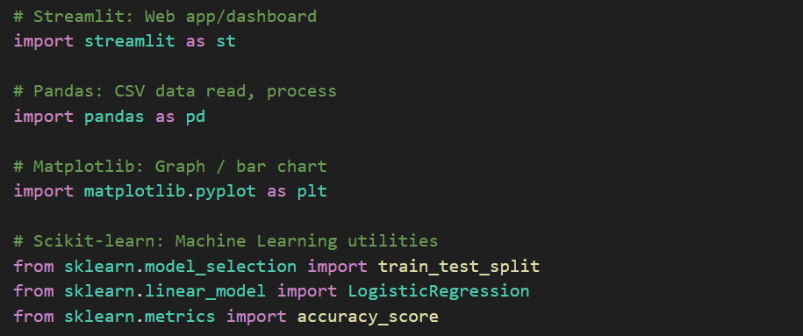
Streamlit is used to create the web-based dashboard that allows user interaction through a browser. Pandas is used for reading and processing CSV datasets. Matplotlib is used to generate visual graphs such as feature importance charts. Scikit-learn provides machine learning utilities such as data splitting, model training, and accuracy evaluation. These libraries together form the core backbone of the system.

6.2 Application Title and Interface Setup
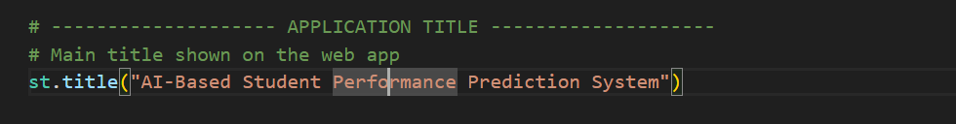
Explanation:
This statement defines the main heading of the application. It helps the user clearly understand the purpose of the system as soon as the application loads. A clear title improves usability and presentation quality.
6.3 CSV Upload Implementation
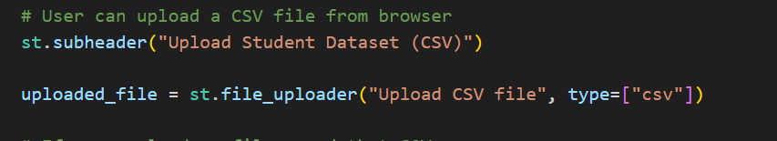
This line creates a file upload option on the web interface. The system restricts uploads to CSV files only, ensuring that the dataset format remains consistent. This design allows non-technical users to upload datasets easily without interacting with the code
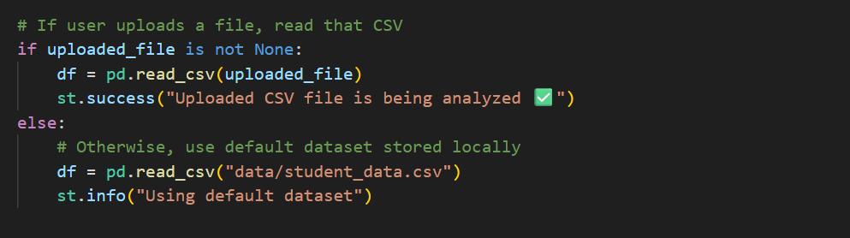
Explanation:
If the user uploads a file, the system reads that dataset dynamically. If no file is uploaded, a default dataset stored locally is used. This ensures that the application always has data available for analysis.
6.4 Data Validation Logic
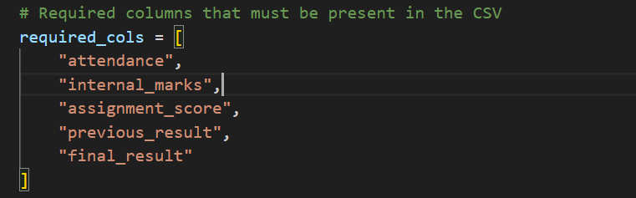
These columns are mandatory for prediction. Each column represents an academic parameter required by the machine learning model.
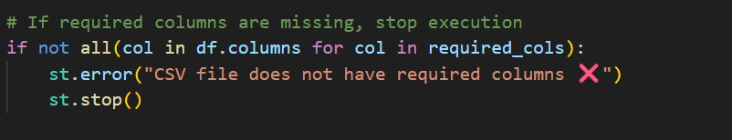
This validation step ensures data correctness. If even one required column is missing, the system stops execution. This prevents runtime errors and ensures that predictions are made only on valid datasets.
6.5 Dataset Preview Implementation
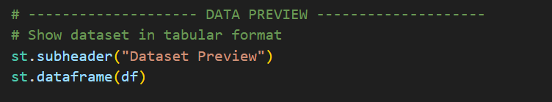
This statement displays the uploaded dataset in a tabular format. It allows users to visually verify the data before further processing. This increases transparency and user confidence in the system.

6.6 Feature and Target Selection
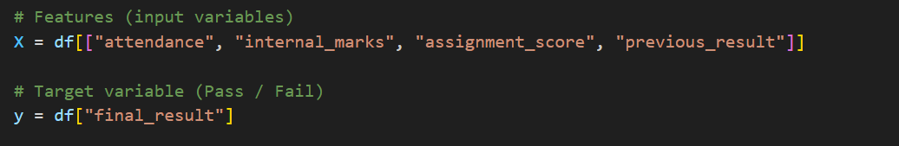
here, independent variables (features) and the dependent variable (target) are separated. The features represent student academic parameters, while the target variable represents the final academic outcome (Pass/Fail). This separation is essential for supervised machine learning.

6.7 Train-Test Split Implementation

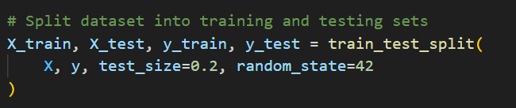
The dataset is divided into training and testing sets. 80% of the data is used for training, while 20% is used for testing. This helps evaluate how well the model performs on unseen data. The random state ensures reproducibility of results.

6.8 Logistic Regression Model Training
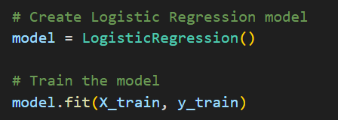
Logistic Regression is used as a classification algorithm because it is suitable for binary outcomes. The model learns the relationship between academic features and student performance during training.
6.9 Model Evaluation
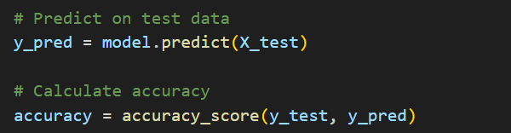The trained model predicts results for the test dataset. Accuracy score measures how many predictions were correct. This metric helps assess the reliability of the model.
6.10 Feature Importance Visualization
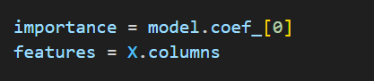
The coefficients of the Logistic Regression model indicate the impact of each academic feature on student performance.
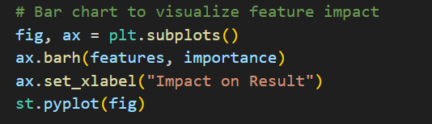
A horizontal bar chart is generated to visualize feature importance. This helps educators understand which academic factors influence performance the most.
6.11 Batch Prediction Logic
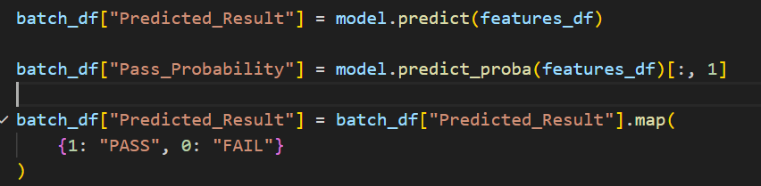
The system predicts performance for all students in the dataset. Probability values indicate confidence in predictions.

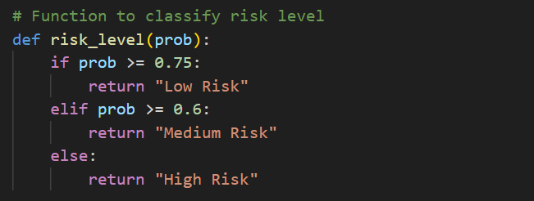
This function classifies students into risk categories based on probability thresholds.

6.12 Individual Student Prediction Implementation
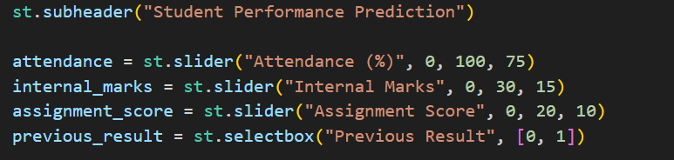
Sliders allow users to input academic parameters interactively. This enables real-time prediction for individual students.

6.13 Report Download Implementation
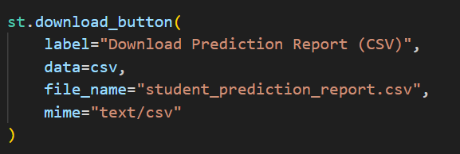
This feature allows users to download prediction results for offline analysis and record-keeping.

6.14 Recommendation Logic
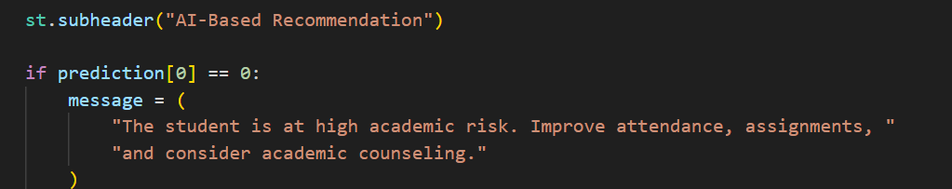
The system generates recommendations based on prediction results. This converts raw predictions into actionable academic guidance.

CHAPTER NO.7
RESULTS

7.1 Dataset Upload and Preview

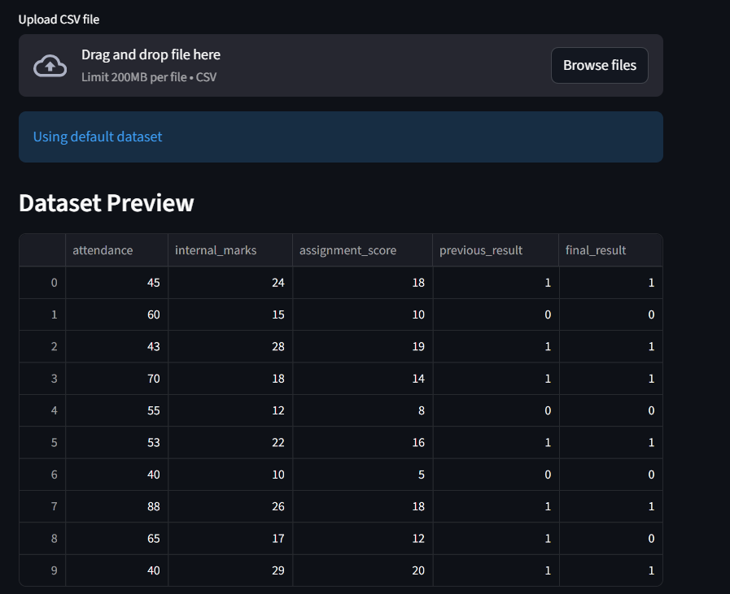
In this output, the system successfully accepts the student dataset in CSV format. After uploading, the dataset is displayed in a tabular form on the screen. This helps to confirm that the correct data has been uploaded and is ready for analysis. Displaying the dataset also improves transparency and avoids errors during prediction.

7.2 Model Accuracy Result


After training the machine learning model, the system displays the accuracy value. This accuracy shows how correctly the model predicts student performance on test data. The obtained accuracy indicates that the Logistic Regression model performs well for academic performance prediction using the given dataset.

7.3 Feature Importance Result

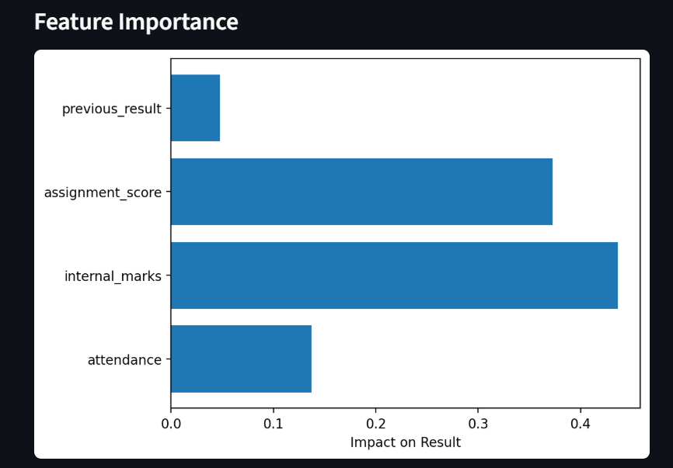
The feature importance graph shows the impact of each academic factor on the prediction result. Attendance, internal marks, assignment score, and previous result are compared using a bar chart. This output helps to understand which academic parameters influence student performance the most.

7.4 Batch Prediction Result

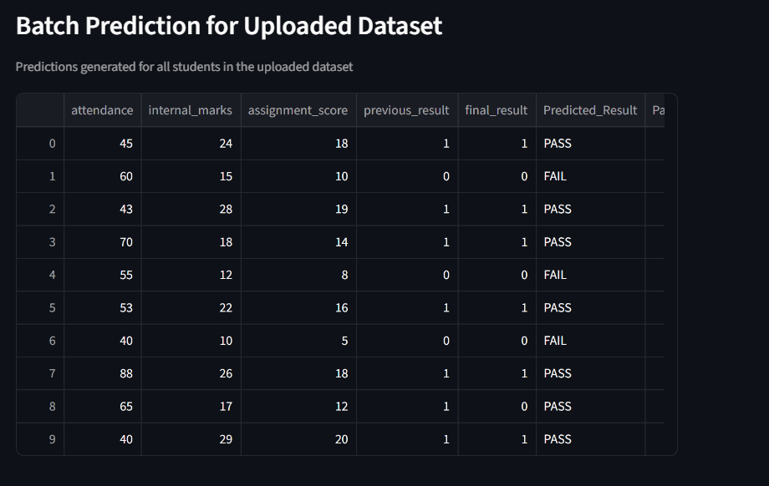

The batch prediction output displays prediction results for all students in the dataset. Each student is assigned a predicted result (PASS or FAIL), probability value, and risk level. This output is useful for teachers to quickly identify high-risk and medium-risk students in the class.

7.5 Individual Student Prediction

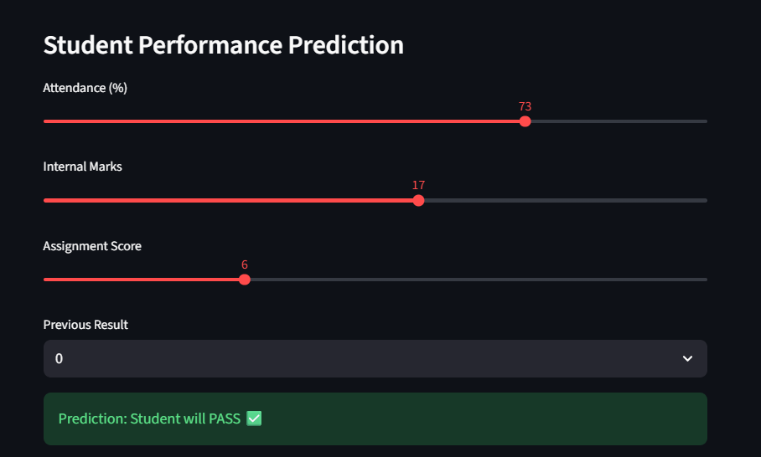

In this output, the system allows prediction for a single student using input sliders. Based on the entered attendance, marks, and previous result, the system predicts whether the student will pass or fail. This feature supports real-time analysis for individual student assessment.

7.6 Auto Insights Summary
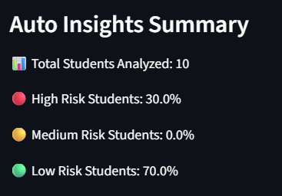
The auto insights section provides a summary of overall class performance. It shows the percentage of students under different risk levels and average academic indicators such as attendance and marks. This output helps in understanding the overall academic condition of the class.

7.7 Recommendation Output

Based on prediction results and risk levels, the system generates simple academic recommendations. These recommendations guide students and teachers on possible improvement actions. This output adds practical value to the system by supporting early academic intervention.

CHAPTER NO.8
CONCLUSION

8.1 Conclusion
This project successfully implemented an AI-Based Student Performance Prediction System using machine learning techniques. The system analyzes student academic data such as attendance, internal marks, assignment scores, and previous results to predict student performance.
The developed system provides both individual and batch-level predictions. It also classifies students into different risk levels and generates simple academic recommendations. The results obtained from the system show that machine learning can be effectively used to support academic decision-making.
The system is easy to use, flexible, and suitable for academic environments. It helps teachers identify weak students at an early stage and take corrective actions. Overall, the project meets its objectives and demonstrates the practical application of artificial intelligence in the education domain.

8.2 Future Scope
In the future, the system can be improved by using larger and real-world datasets to increase prediction accuracy. Additional academic and non-academic parameters such as behavioral data and learning patterns can also be included. Advanced machine learning and deep learning models can be applied to improve performance.
The system can be integrated with college management systems for automatic data collection. A mobile or web-based version can also be developed for wider accessibility. These enhancements will make the system more powerful and useful for educational institutions.
CHAPTER NO.9
REFERENCES
• Han, J., Kamber , M., and Pei, J., Data Mining: Concepts and Techniques, Morgan Kaufmann Publishers, 3rd Edition, 2011.
• Bishop, C. M., Pattern Recognition and Machine Learning, Springer, 2006.
• Géron, A., Hands-On Machine Learning with Scikit-Learn and Python, O’Reilly Media, 2017.
• James, G., Witten, D., Hastie, T., and Tibshirani, R., An Introduction to Statistical Learning, Springer, 2013.
• Scikit-learn Documentation,
https://scikit-learn.org/
• Streamlit Documentation,
https://docs.streamlit.io/
• Pandas Documentation,
https://pandas.pydata.org/docs/
• Matplotlib Documentation,
https://matplotlib.org/stable/
• Kumar, S. and Singh, R., “Student Performance Prediction Using Machine Learning Techniques,” International Journal of Computer Applications, 2019.
• Research papers and online articles related to student performance prediction and educational data analytics.

